**UNIT-V**

**SKY WAVE PROPAGATION**

**Ionosphere**

This is the upper layer of the Earth’s atmosphere, where ionization is appreciable. The energy radiated by the Sun, not only heats this region, but also produces positive and negative ions. Since the Sun constantly radiates UV rays and air pressure is low, this layer encourages ionization of particles.

**Importance of Ionosphere**

The ionosphere layer is a very important consideration in the phase of wave propagation because of the following reasons −

* The layer below ionosphere has higher amount of air particles and lower UV radiation. Due to this, more collisions occur and ionization of particles is minimum and not constant.
* The layer above ionosphere has very low amount of air particles and density of ionization is also quite low. Hence, ionization is not proper.
* The ionosphere has good composition of UV radiation and average air density that does not affect the ionization. Hence, this layer has most influence on the Sky wave propagation.

The ionosphere has different gases with different pressures. Different ionizing agents ionize these at different heights. As various levels of ionization are done at each level, having different gases, few layers with different properties are formed in the ionosphere.

The layers of ionosphere can be studied from the following figure.

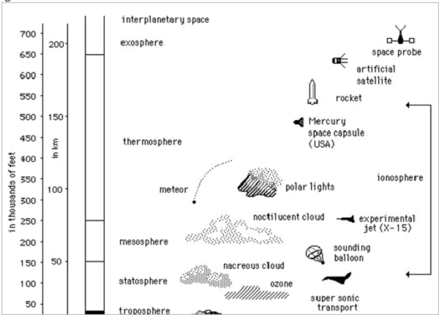

The number of layers, their heights, the amount of sky wave that can be bent will vary from day to day, month to month and year to year. For each such layer, there is a frequency, above which if the wave is sent upward vertically, it penetrates through the layer.

The function of these layers depends upon the time of the day, i.e., day time and night time. There are three principal layers- E, F1 and F2 during day time. There is another layer called D layer, which lies below E layer. This layer is at 50 to 90kms above the troposphere.

The following figure depicts the layers present in both day time and night time in the earth’s atmosphere.

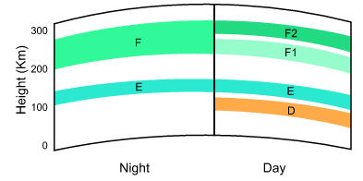

This D layer is responsible for the day time attenuation of HF waves. During night time, this D layer almost vanishes out and the F1 and F2 layers combine together to form F layer. Hence, there are only two **layers E and F** present at the **night time**.

[REFRACTION IN THE IONOSPHERE](http://electriciantraining.tpub.com/14182/css/Refraction-In-The-Ionosphere-80.htm) : (Mechanism of Wave Refraction in Ionosphere)

When a radio wave is transmitted into an ionized layer, refraction, or bending of the wave, occurs. As we discussed earlier, refraction is caused by an abrupt change in the velocity of the upper part of a radio wave as it strikes or enters a new medium. The amount of refraction that occurs depends on three main factors: (1) the density of ionization of the layer, (2) the frequency of the radio wave, and (3) the angle at which the wave enters the layer.

Density of Layer

Figure 2-15 illustrates the relationship between radio waves and ionization density. Each ionized layer has a central region of relatively dense ionization, which tapers off in intensity both above and below the maximum region. As a radio wave enters a region of INCREASING ionization, the increase in velocity of the upper part of the wave causes it to be bent back TOWARD the Earth. While the wave is in the highly dense center portion of the layer, however, [refraction](http://meteorologytraining.tpub.com/14271/css/14271_64.htm) occurs more slowly because the density of ionization is almost uniform. As the wave enters into the upper part of the layer of DECREASING ionization, the velocity of the upper part of the wave decreases, and the wave is bent AWAY from the Earth.

Figure 2-15. - Effects of ionospheric density on radio waves.

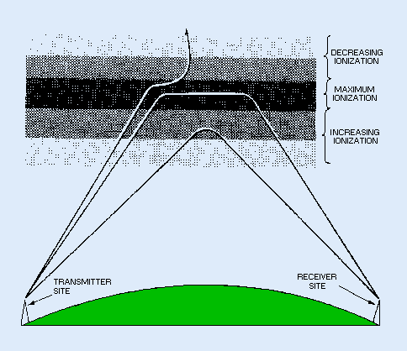

If a wave strikes a thin, very highly ionized layer, the wave may be bent back so rapidly that it will appear to have been reflected instead of refracted back to Earth. To reflect a radio wave, the highly ionized layer must be approximately no thicker than one [wavelength](http://electriciantraining.tpub.com/14184/css/Wavelength-20.htm) of the radio wave. Since the ionized layers are often several miles thick, ionospheric reflection is more likely to occur at long [wavelengths](http://electriciantraining.tpub.com/14184/css/Wavelength-20.htm) (low frequencies).

Frequency

For any given time, each ionospheric layer has a maximum frequency at which [radio waves](http://electriciantraining.tpub.com/14182/css/Radio-Waves-66.htm) can be transmitted vertically and refracted back to Earth. This frequency is known as the CRITICAL FREQUENCY. It is a term that you will hear frequently in any discussion of radio wave propagation. Radio waves transmitted at frequencies higher than the critical frequency of a given layer will pass through the layer and be lost in space; but if these same waves enter an upper layer with a higher critical frequency, they will be refracted back to Earth. [Radio waves](http://armyengineer.tpub.com/TC-9-64/TC-9-640065.htm) of frequencies lower than the critical frequency will also be refracted back to Earth unless they are absorbed or have been refracted from a lower layer. The lower the frequency of a radio wave, the more rapidly the wave is refracted by a given degree of ionization. Figure 2-16 shows three separate waves of different frequencies entering an ionospheric layer at the same angle. Notice that the 5-megahertz wave is refracted quite sharply. The 20-megahertz wave is refracted less sharply and returned to Earth at a greater distance. The 100-megahertz wave is obviously greater than the critical frequency for that ionized layer and, therefore, is not refracted but is passed into space.

Figure 2-16. - Frequency versus refraction and distance.

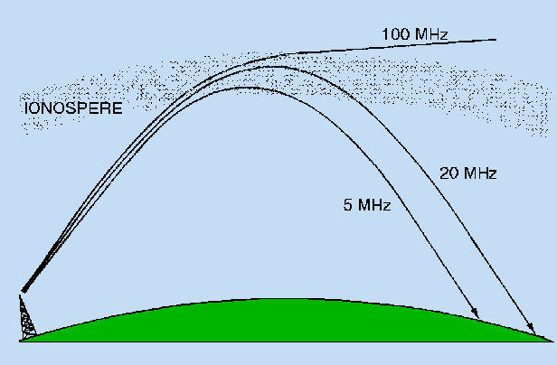

[Angle of Incidence](http://armyengineer.tpub.com/TC-9-64/TC-9-640082.htm)

The rate at which a wave of a given frequency is refracted by an ionized layer depends on the angle at which the wave enters the layer. Figure 2-17 shows three radio waves of the same [frequency](http://armyaviation.tpub.com/Av1959/Frequency-31.htm) entering a layer at different angles. The angle at which wave A strikes the layer is too nearly vertical for the wave to be refracted to Earth. As the wave enters the layer, it is bent slightly but passes through the layer and is lost. When the wave is reduced to an angle that is less than vertical (wave B), it strikes the layer and is refracted back to Earth. The angle made by wave B is called the CRITICAL ANGLE for that particular frequency. Any wave that leaves the [antenna](http://electriciantraining.tpub.com/14182/css/Chapter-4-Antennas-167.htm) at an angle greater than the critical angle will penetrate the ionospheric layer for that [frequency](http://armyaviation.tpub.com/Av1959/Frequency-31.htm) and then be lost in space. Wave C strikes the [ionosphere](http://armycommunications.tpub.com/ss0130a/Ionosphere-40.htm) at the smallest angle at which the wave can be refracted and still return to Earth. At any smaller angle, the wave will be refracted but will not return to Earth.

Figure 2-17. - Different incident angles of radio waves.

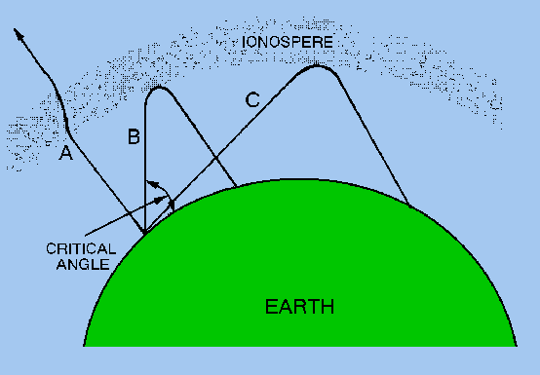

As the frequency of the [radio wave](http://electriciantraining.tpub.com/14182/css/Radio-Waves-66.htm) is increased, the critical angle must be reduced for refraction to occur. This is illustrated in figure 2-18. The 2-megahertz wave strikes the layer at the critical angle for that frequency and is refracted back to Earth. Although the 5-megahertz wave (broken line) strikes the [ionosphere](http://armycommunications.tpub.com/ss0130a/Ionosphere-40.htm) at a lesser angle, it nevertheless penetrates the layer and is lost. As the angle is lowered from the vertical, however, a critical angle for the 5-megahertz wave is reached, and the wave is then refracted to Earth.

Figure 2-18. - Effects of frequency on the critical angle.

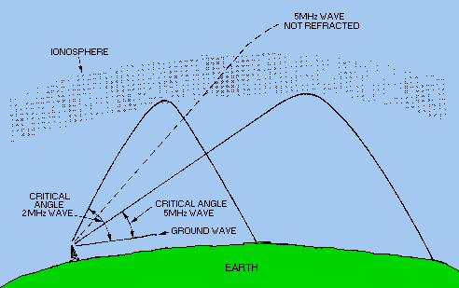

**Virtual Height**

When a wave is refracted, it is bent down gradually, but not sharply. However, the path of incident wave and reflected wave are same if it is reflected from a surface located at a greater height of this layer. Such a greater height is termed as virtual height.

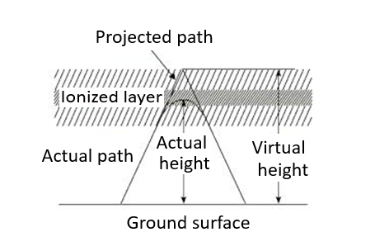

The figure clearly distinguishes the **virtual height** (height of wave, supposed to be reflected) and **actual height** (the refracted height). If the virtual height is known, the angle of incidence can be found.

The transmission path distance, *TR=*2*h*/tan β

Where β=Angle of elevation

*h* =Virtual height

**Critical Frequency**

Critical frequency for a layer determines the highest frequency that will be returned down to the earth by that layer, after having been beamed by the transmitter, straight up into the sky.

The rate of ionization density, when changed conveniently through the layers, the wave will be bent downwards. The maximum frequency that gets bent and reaches the receiver station with minimum attenuation, can be termed as **critical frequency**. This is denoted by **fc**.

When the refractive index, *n* has decreased to the point where *n =* sin *φi the* angle of refraction *φ* will be 90° and wave will be travelling horizontally. The higher point reached by the wave is free. The electron density *N* at the that point satisfies the relation





If the electron density at some level in a layer is sufficient great to satisfy the above condition. then the wave will be returned to earth from that level. If maximum electron density in a layer is less than n', the wave will penetrate the layer (Though it may be reflected back from a higher layer for which N is greater). The largest electron density required for reflection occurs when the angle of incident φi is zero, i.e., for vertical incidence. For any given layer the highest frequency that will be reflected back for vertical incidence will be

**

The characteristics of the ionospheric layers are usually described in terms of their virtual heights and critical frequencies, as these quantities can be readily measured. The virtual height is the height that would be reached by a short pulse of energy showing the same time delay as the

actual pulse reflected from the layer travelling with the speed of light. The virtual height is always greater than the true height of reflection, because the interchange of energy taking place between the wave and electrons of the ionosphere causes the velocity of propagation to be reduced. The extent of this difference is influenced, by the electron distributions in the regions below the level of reflection. It is usually very small, but on occasions may be as large as 100 Kms or so.



The critical frequencies of the E and F1 layers primarily depend on the zenith angle of the sun. It,

therefore, follows a regular diurnal cycle, being maximum at noon and tapering off an either side. The *fc* of the F2 layer, shows much larger seasonal variation and also changes more from day to day. It can be seen that the critical frequencies of the regular layers decrease greatly during night as a result of recombination in the absence of solar radiation.

But the *fc* of sporadic E shows regular variation throughout the day and night suggesting that sporadic *E* is affected strongly by factors other than solar radiation. There is a long term variation in all ionospheric characteristics closely associated with the *11 year sunspot cycle.* From the minimum to maximum of the cycle, *fc* of *F2* layer varies from about 6 to 11 MHz (ratio of 1:1.8), *fc* of *E* layer varies from 3.1 to 3.8 MHz (a ratio of mere 1 to 1.2). Long term predictions of ionospheric characteristics are based on predictions of the sunspot number. Reliable estimates can be made, for as much as a year, in advance.

**Multi-path**

For the frequencies above 30 MHz, the sky wave propagation exists. Signal multipath is the common problem for the propagation of electromagnetic waves going through Sky wave. The wave, which is reflected from the ionosphere, can be called as a **hop** or **skip**. There can be a number of hops for the signal as it may move back and forth from the ionosphere and earth surface many times. Such a movement of signal can be termed as **multipath**.

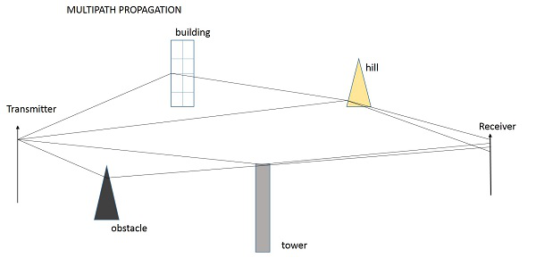

The above figure shows an example of multi-path propagation. Multipath propagation is a term, which describes the multiple paths a signal travels to reach the destination. These paths include a number of hops. The paths may be the results of reflection, refraction or even diffraction. Finally, when the signal from such different paths gets to the receiver, it carries propagation delay, additional noise, phase differences etc., which decrease the quality of the received output.

**Fading**

The decrease in the quality of the signal can be termed as **fading**. This happens because of atmospheric effects or reflections due to multipath.

Fading refers to the variation of the signal strength with respect to time/distance. It is widely prevalent in wireless transmissions. The most common causes of fading in the wireless environment are multipath propagation and mobility (of objects as well as the communicating devices).

**Skip Distance**

The measurable distance on the surface of the Earth from transmitter to receiver, where the signal reflected from the ionosphere can reach the receiver with minimum hops or skips, is known as **skip distance**.

In figure 2-19, note the relationship between the sky wave skip distance, the skip zone, and the ground wave coverage. The SKIP DISTANCE is the distance from the [transmitter](http://electriciantraining.tpub.com/14189/css/Transmitters-76.htm) to the point where the [sky wave](http://electriciantraining.tpub.com/14182/css/Sky-Waves-101.htm) is first returned to Earth. The size of the skip distance depends on the frequency of the wave, the [angle of incidence](http://armyengineer.tpub.com/TC-9-64/TC-9-640082.htm), and the degree of ionization present.

Figure 2-19. - Relationship between skip zone, skip distance, and ground wave.

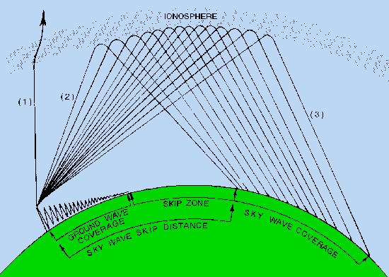

The [SKIP ZONE](http://electriciantraining.tpub.com/14182/css/Skip-Zone-103.htm) is a zone of silence between the point where the ground wave becomes too weak for reception and the point where the sky wave is first returned to Earth. The size of the [skip zone](http://electriciantraining.tpub.com/14182/css/Skip-Zone-103.htm) depends on the extent of the ground wave coverage and the skip distance. When the ground wave coverage is great enough or the skip distance is short enough that no zone of silence occurs, there is no skip zone.

Occasionally, the first sky wave will return to Earth within the range of the ground wave. If the sky wave and ground wave are nearly of equal intensity, the sky wave alternately reinforces and cancels the ground wave, causing severe fading. This is caused by the phase difference between the two waves, a result of the longer path traveled by the sky wave.

[PROPAGATION PATHS](http://armyengineer.tpub.com/TC-9-64/TC-9-640084.htm)

The path that a refracted wave follows to the receiver depends on the angle at which the wave strikes the [ionosphere](http://armycommunications.tpub.com/ss0130a/Ionosphere-40.htm). You should remember, however, that the rf energy radiated by a transmitting antenna spreads out with distance. The energy therefore strikes the ionosphere at many different angles rather than a single angle.

After the rf energy of a given frequency enters an ionospheric region, the paths that this energy might follow are many. It may reach the receiving antenna via two or more paths through a single layer. It may also, reach the receiving antenna over a path involving more than one layer, by multiple hops between the ionosphere and Earth, or by any combination of these paths.

Figure 2-20 shows how [radio waves](http://armyengineer.tpub.com/TC-9-64/TC-9-640065.htm) may reach a receiver via several paths through one layer. The various angles at which rf energy strikes the layer are represented by dark lines and designated as rays 1 through 6.

Figure 2-20. - Ray paths for a fixed frequency with varying angles of incidence.

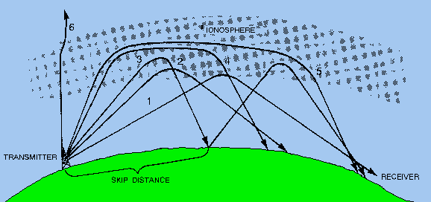

When the angle is relatively low with respect to the horizon (ray 1), there is only slight penetration of the layer and the propagation path is long. When the angle of incidence is increased (rays 2 and 3), the rays penetrate deeper into the layer but the range of these rays decreases. When a certain angle is reached (ray 3), the penetration of the layer and rate of refraction are such that the ray is first returned to Earth at a minimal distance from the [transmitter](http://electriciantraining.tpub.com/14189/css/Transmitters-76.htm). Notice, however, that ray 3 still manages to reach the receiving site on its second [refraction](http://meteorologytraining.tpub.com/14271/css/14271_64.htm) (called a hop) from the ionospheric layer.

As the angle is increased still more (rays 4 and 5), the rf energy penetrates the central area of maximum ionization of the layer. These rays are refracted rather slowly and are eventually returned to Earth at great distances. As the angle approaches vertical incidence (ray 6), the ray is not returned at all, but passes on through the layer.

**Maximum Usable Frequency (MUF)**

Although the critical frequency for any layer represents the highest frequency that will be reflected back from that layer at vertical incidence, it is not the highest frequency that can be reflected from the layer. The highest frequency that can be reflected depends also upon the angle of incidence, and hence, for a given layer height, upon the distance between the transmitting and receiving points.

The maximum, frequency that can be reflected back for a given distance of transmission is called the maximum usable frequency (MUF) for that distance.

It is seen that the MUF is related to the critical frequency and the angle of incidence by the simple expression



The MUF for a layer is greater than the critical frequency by the factor secφ i the largest angle of

incidence φ i that can be obtained in F-layer reflection is of the order of 74°. This occurs for a ray that leaves the earth at the grazing angle. The geometry for this case is shown by Fig. 1.2







**Optimum Working Frequency (OWF)**

The frequency, which is being used mostly for a particular transmission and which has been predicted to be used over a particular period of time, over a path, is termed as **Optimum Working Frequency (OWF)**.

**Inter Symbol Interference**

**Inter symbol interference** (ISI) occurs more commonly in communication system. This is the main reason for signal multipath also. When signals arrive at the receiving stations via different propagation paths, they cancel out each other, which is known as the phenomenon of **signal fading**. Here, it should be remembered that the signals cancel out themselves in vector way.

**Skin Depth**

Electromagnetic waves are not suitable for underwater propagations. However, they can propagate under water provided we make the frequency of propagation extremely low. The attenuation of electromagnetic waves under water is expressed in terms of skin depth. **Skin depth** is defined as the distance at which the signal is attenuated by 1/e. It is a measure of depth to which an EM wave can penetrate. Skin depth is represented as **δ** (delta).

**Duct Propagation**

At a height of around 50 mts from the troposphere, a phenomenon exists; the temperature increases with the height. In this region of troposphere, the higher frequencies or microwave frequencies tend to refract back into the Earth’s atmosphere, instead of shooting into ionosphere, to reflect. These waves propagate around the curvature of the earth even up to a distance of 1000km.

This refraction goes on continuing in this region of troposphere. This can be termed as **Super refraction** or **Duct propagation**.

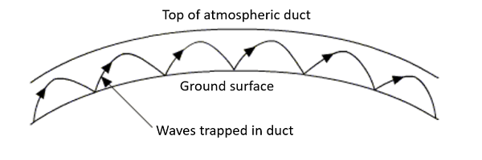

The above image shows the process of **Duct Propagation**. The main requirement for the duct formation is the temperature inversion. The increase of temperature with height, rather than the decrease in the temperature is known as the phenomenon of temperature inversion.

## Faraday rotation in the ionosphere:

[Radio waves](https://en.wikipedia.org/wiki/Radio_wave) passing through the Earth's [ionosphere](https://en.wikipedia.org/wiki/Ionosphere) are likewise subject to the Faraday effect. The ionosphere consists of a [plasma](https://en.wikipedia.org/wiki/Plasma_%28physics%29) containing free electrons which contribute to Faraday rotation according to the above equation, whereas the positive ions are relatively massive and have little influence. In conjunction with the earth's magnetic field, rotation of the polarization of radio waves thus occurs. Since the density of electrons in the ionosphere varies greatly on a daily basis, as well as over the [sunspot cycle](https://en.wikipedia.org/wiki/Sunspot_cycle), the magnitude of the effect varies. However the effect is always proportional to the square of the wavelength, so even at the UHF television frequency of 500 MHz (λ = 60 cm), there can be more than a complete rotation of the axis of polarization.[[12]](https://en.wikipedia.org/wiki/Faraday_effect#cite_note-12) A consequence is that although most radio transmitting antennas are either vertically or horizontally polarized, the polarization of a medium or short wave signal after [reflection by the ionosphere](https://en.wikipedia.org/wiki/Skywave) is rather unpredictable. However the Faraday effect due to free electrons diminishes rapidly at higher frequencies (shorter wavelengths) so that at [microwave](https://en.wikipedia.org/wiki/Microwave) frequencies, used by [satellite communications](https://en.wikipedia.org/wiki/Satellite_communications), the transmitted polarization is maintained between the satellite and the ground.

**Effect of Earth’s Magnetic Field:**

The highest frequency waves reacted from the ionosphere are high-frequency (HF) waves which cover the range of 3_30 MHz. The properties of the ionosphere have been investigated by examining factors reacting the propagation and reaction of the radio waves in this HF band reacted from the ionosphere.

The HF radio wave is exposed to many physical events in the ionosphere until it reaches the receiver by reacting from the ionosphere after sending from the transmit- ter. The most important one of these is absorption. The HF radio wave passing through the ionosphere transfers the electrons and ions in free state within weakly ionized plasma as a part of its energy. The transferred energy increases the average kinetic energy of electrons and ions in free state. If the electrons and ions with increased energy do not collide with low-energy neutral particles, then a large part of lost energy of the radio wave is converted to the electromagnetic energy and continues to the propagation too much unchanged intensity of the wave. However, if the electrons and ions collide with neutral particles, then a large part of this energy is lost and the wave energy is absorbed.

High-powerful radio waves increase the temperature and change the electron and ion densities through the collisions of the electrons with the ions and with the neutral molecules and atoms in the perturbed region of the ionosphere. This alters the high-powerful radio waves absorption. Thus, the heating of the ionosphere in the field of high-powerful radio waves should excite new plasma oscillations and enhance those already present there, and give rise to formation of an oscillating turbulized region. This strongly incenses the conditions of radio wave propagation in the perturbed region of plasma, causing them to become more strongly absorbed and scattered .

The above-mentioned effects are only a few of the non- linear effects occurring in the ionospheric plasma. Non- linear effects were observed by Gurevich et al . They were described as effects of the self-action of a high power radio wave. These effects lead to a sharp increase of the wave absorption under certain conditions and de- crease of absorption (plasma _translucence_ effect) under others .